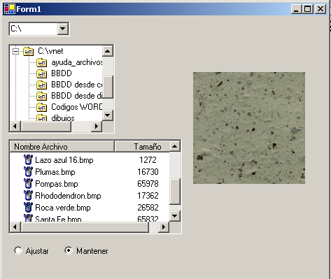

Imports System.IO
Public Class Form1
Inherits System.Windows.Forms.Form

#Region " Código generado por el Diseñador de Windows Forms "

Private Sub Form1_Load(ByVal sender As System.Object, ByVal e As System.EventArgs) Handles MyBase.Load
Dim Unidades() As String
OptMantener.Checked = True
Unidades = System.Environment.GetLogicalDrives
CboUnidades.Items.AddRange(Unidades)
TreeView.ImageList = ImageList

ListView.View = View.Details
ListView.Columns.Add(New ColumnHeader)
ListView.Columns(0).Text = "Nombre Archivo"
ListView.Columns(0).TextAlign = HorizontalAlignment.Center
ListView.Columns(0).Width = 150
ListView.Columns.Add(New ColumnHeader)
ListView.Columns(1).Text = "Tamaño"
ListView.Columns(1).TextAlign = HorizontalAlignment.Center
ListView.Columns(1).Width = -2
ListView.Sorting = SortOrder.Ascending

ListView.LargeImageList = ImageList
ListView.SmallImageList = ImageList
ListView.StateImageList = ImageList
End Sub

Private Sub CboUnidades_SelectedIndexChanged(ByVal sender As System.Object, ByVal e As System.EventArgs) Handles CboUnidades.SelectedIndexChanged
Dim oDirUnidades As New DirectoryInfo(CboUnidades.Text)
Dim oDirectorios() As DirectoryInfo
oDirectorios = oDirUnidades.GetDirectories
TreeView.Nodes.Clear()

Dim oDirInfor As DirectoryInfo
Dim oNodo As TreeNode
For Each oDirInfor In oDirectorios
oNodo = New TreeNode(oDirInfor.FullName, 0, 0)
TreeView.Nodes.Add(oNodo)

Next
End Sub

Private Sub TreeView_AfterSelect(ByVal sender As System.Object, ByVal e As System.Windows.Forms.TreeViewEventArgs) Handles TreeView.AfterSelect
If Not e.Node.IsExpanded Then
Dim oSubDirInfo As DirectoryInfo
oSubDirInfo = New DirectoryInfo(e.Node.FullPath)

Dim oSubDirectorios() As DirectoryInfo
oSubDirectorios = oSubDirInfo.GetDirectories

Dim oSubDir As DirectoryInfo
Dim oNodo As TreeNode
For Each oSubDir In oSubDirectorios
oNodo = New TreeNode(oSubDir.Name, 0, 0)
e.Node.Nodes.Add(oNodo.Text)
Next
Dim oArchivos() As FileInfo
oArchivos = oSubDirInfo.GetFiles
ListView.Items.Clear()

Dim oarchivoinfo As FileInfo
For Each oarchivoinfo In oArchivos

Select Case oarchivoinfo.Extension.ToUpper
Case ".BMP", ".PNG", ".WMF)"
Dim Item1 As New ListViewItem(oarchivoinfo.Name, 1)
Item1.SubItems.Add(oarchivoinfo.Length)
'ListView.Items.AddRange(New ListViewItem() {Item1})
ListView.Items.Add(Item1)

Case ".JPG", ".JPEG"
Dim Item2 As New ListViewItem(oarchivoinfo.Name, 3)
Item2.SubItems.Add(oarchivoinfo.Length)
ListView.Items.Add(Item2)

Case ".GIF"
Dim Item3 As New ListViewItem(oarchivoinfo.Name, 2)
Item3.SubItems.Add(oarchivoinfo.Length)
ListView.Items.Add(Item3)

End Select

Next
End If
End Sub

Private Sub ListView_SelectedIndexChanged(ByVal sender As System.Object, ByVal e As System.EventArgs) Handles ListView.SelectedIndexChanged
If ListView.SelectedItems.Count > 0 Then
PicImagen.Invalidate()
PicImagen.Image = New Bitmap(TreeView.SelectedNode.FullPath & "\" & ListView.SelectedItems(0).Text)
End If
End Sub

Private Sub PicImagen_Paint(ByVal sender As Object, ByVal e As System.Windows.Forms.PaintEventArgs) Handles PicImagen.Paint
If Not (IsNothing(TreeView.SelectedNode)) Then
Dim oBitmap As New Bitmap(TreeView.SelectedNode.FullPath & "\" & ListView.SelectedItems(0).Text)
Dim oGraf As Graphics = e.Graphics
If OptAjustar.Checked Then
oGraf.DrawImage(oBitmap, 0, 0, PicImagen.Size.Width, PicImagen.Size.Height)
Else

oGraf.DrawImage(oBitmap, 0, 0, oBitmap.Size.Width, oBitmap.Size.Height)

End If
End If

End Sub

Private Sub OptAjustar_Click(ByVal sender As Object, ByVal e As System.EventArgs) Handles OptAjustar.Click
PicImagen.Invalidate()
End Sub

Private Sub OptMantener_Click(ByVal sender As Object, ByVal e As System.EventArgs) Handles OptMantener.Click
PicImagen.Invalidate()
End Sub
End Class

